Maribor, 18th – 19th of September 2013

INTERNATIONAL FINAL CONFERENCE OF THE PMinter PROJECT
Program

Day One – Wednesday, 18. 9. 2013 / 9.00 – 18.00

9.00 Registration of Participants
9.15 – 9.45 Press Conference
10.00 – 10.30 Welcome Speeches

10.30 – 12.00 1st session – Air quality monitoring, part one

Anton Planinšek  Slovenian Environment Agency, Slovenia | Air quality monitoring in Slovenia
Mag. Benjamin Lukan, Uroš Lešnik  Institute of Public Health Maribor, Slovenia | Air quality monitoring in Maribor
Gerhard Heimburger  Office of the Carinthian Government Amt der Kärntner Landesregierung, Austria | PM₁₀ and B(a)P in Carinthia
Dr. Griša Močnik  Aerosol, Slovenia | Source apportionment of PM air pollution in Slovenia and Austria using aerosol light absorption measurements

12.00 – 12.15 Coffee Break

12.15 – 13.30 1st session – Air quality monitoring, part two

Dr. Anne Kasper-Giebl  TU Vienna, Austria | Macro tracer model for particulate matter source apportionment (PM10) at 7 PMinter air quality measurement stations (February 2011)
Dr. Magdalena Kistler  TU Vienna, Austria | Chemical characterization of PM₁₀ emissions from small-scale domestic wood combustion – factors for the Macro-tracer concept
Dr. Thomas Brunner  TU Graz, Austria | PM emission measurements at small-scale biomass boilers in Carinthia, southern Styria and Slovenia
13.30 – 14.30 lunch

14.30 – 15.30 2nd session – Impacts on health

Dr. Ivan Eržen dr. Peter Otorepec  Institute for health protection Ljubljana, Slovenia  dr. Vesna Lesjak  Institute of Public Health Maribor, Slovenia | Ultrafine particles in the air and health
Dr. Hans Peter Hutter  Medical University of Vienna, Austria | Health effects of particulate matter: exposure and research in Austria

15.30 – 17.30 3rd session – Modelling

Dr. Rahela Žabkar  University of Ljubljana, Slovenia | Regional modelling of excessive air pollution episodes in Slovenia
Ondřej Vlček  Czech Hydrometeorological Institute, Chech Republic | Forecasting PM in the Czech Republic
Dr. Ulrich Uhrner  TU Graz, Austria | Modelling in PMinter a holistic approach –from base data to emissions to exposure considering local, regional and long range transport and chemistry

17.30– 18.00 Summary of the first day

19.00 Dinner

Day Two – Thursday, 19. 9. 2013 / 9.00 – 13.15

9.00 – 11.00 4th session – Measures, part one

Mag. Jože Jurša  Ministry of Agriculture and Environment, Slovenia | Joint planning and implementation of the air quality on the level of the state and the city of Maribor
Brigita Čanč, spec.  Municipality of Maribor, Slovenia  Marjan Lep  University of Maribor, Slovenia | Preparation of Air quality management plan for Maribor
Dr. Marjan Lep, Marko Čelan, dr. Marko Renčelj and dr. Branka Trček  University of Maribor, Slovenia | Pilot environmental zone in Maribor

11.00 – 11.15 Coffee Break

11.15 – 12.00 4th session – Measures, part two

Dr. Wolfgang Hafner  Municipality of the City of Klagenfurt, Austria | Finedustfree Klagenfurt? - Activities to Reduce Air Pollution in the City of Klagenfurt, Austria
Dr. Thomas Pongratz  Styrian Government , Austria | The Styrian Air Quality Management Plan 2011 – Meaures to improve air quality

12.00 – 13.00 5th session – Best practices

Dr. Ulrich Teichmann  City of Munich, Germany | Air pollution in the City of Munich since 2004
Irena Razpotnik  Municipality of Ljubljana , Slovenia | Sustainable Mobility Plan - Strategy of electromobility in the Municipality of Ljubljana  The project Bicike(LJ) - Successes from 2011 and expansion plan

13.00 – 13.15 Summary of the second day

13.15 – 14.00 Lunch

From 15.00 Activities in connection with European mobility week

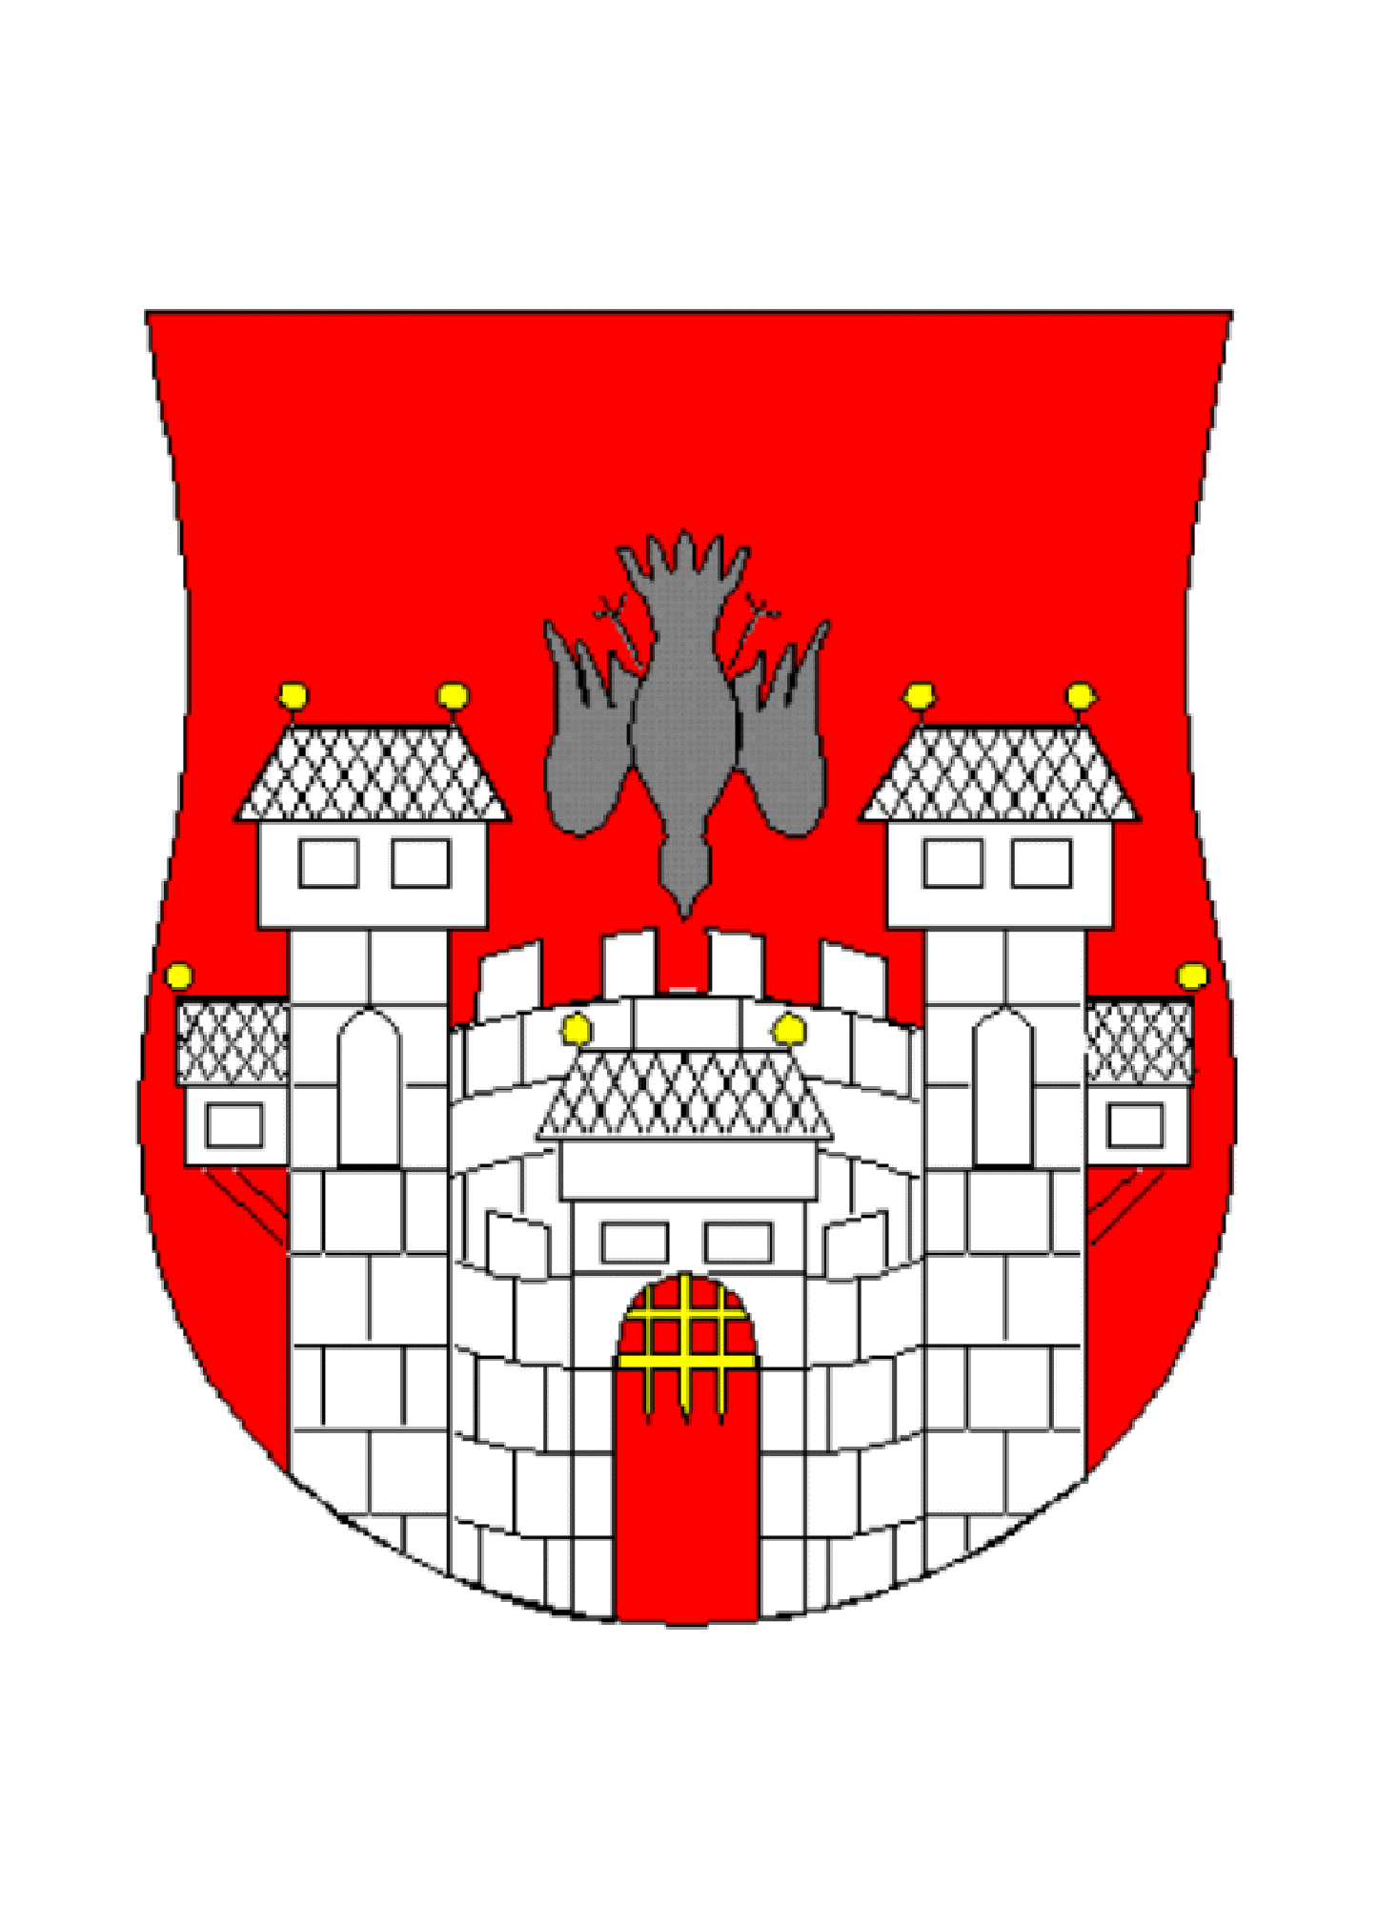
MUNICIPALITY OF
MARIBOR
MUNICIPALITY OF MARIBOR

