

**Macrotracer Model for Fine Dust Source Mapping (PM10) at 7 PMinter Air Quality Measuring Stations (February 2011)**

**Anne Kasper-Giebl1, Magdalena Kistler1, Eylem Can Cetintas1, Elisabeth Schreiner1, Carlos Ramirez Santa-Cruz1, Sönke Szidat2, Yanlin Zhang2, Heidi Bauer1†**

**1Vienna University of Technology, Institute of Chemical Technologies and Analytical Chemistry, Getreidemarkt 9/164-UPA, A-1060 Vienna**

**2University of Berne, Department of Chemistry and Biochemistry, Freiestraße 3, CH-3012 Berne**

[**akasper@mail. tuwien.ac.at**](mailto:akasper@mail.zserv.tuwien.ac.at)

***Abstract***

To characterise the most important sources of fine dust in the Austrian/Slovenian border region, filter measurements were conducted in February 2011 at seven measuring points in Lower Carinthia, Southern Styria and Northern Slovenia. The effective fine dust sources were derived from a chemical analysis of these filters using a macrotracer model. The analyses included the determination of soot, organic carbon, anhydrous dextrose, HULIS, inorganic ions and selected metals. It was possible to show inorganic ions (ammonium nitrate and ammonium sulphate – formed from gaseous precursor substances) and wood smoke to be the most important sources of fine dust. Furthermore, motor vehicle traffic contributed to the formation of fine dust. In addition 14C measurements were conducted in order to differentiate the proportion of fine dust that contains carbon from fossil and non-fossil sources.

**Introduction**

PM10 – fine dust with an aerodynamic diameter of 10 µm and less is considered to be a hazard to the environment and human health. The existing short-term threshold value (50 µg/m³ over 24 hours – 2008/50/EC) must not be exceeded more than 35 times per year in EU countries and not more than 25 times per year in Austria in accordance with the Austrian Ambient Air Quality Act. Unfortunately, the number of permitted overrun days is not complied with in many areas of Europe, also including the Austrian/Slovenia border regions (Lower Carinthia, Southern Styria and Northern Slovenia). Therefore the EU project *PMinter* deals with the development of measures for effective improvement of the air quality. The results are to facilitate future compliance with EU limiting values for air pollutants with special consideration given to fine dust (PM10). To do this, it is necessary to quantify the contribution of the different sources of fine dust to the increased background pollution, as well as the additional pollution in urban centres. A chemical macrotracer model was used in the *PMinter* project, among other things, to clarify this question.

**Methods**

The chemical analysis was based on quartz fibre filters that were sampled between 28 January and 28 February 2011 as well as on 21 and 22 July 2011 at seven air quality measuring stations in Styria, Northern Slovenia and Carinthia. The stations were at Klagenfurt Völkermarkter Straße, Klagenfurt Ost (Limmersdorf) and Ebenthal-Zell in Carinthia, Leibnitz and Arnfels-Remschnigg in Styria, as well as Maribor Center and Vrbanski Plato in Slovenia. After gravimetric determination of the fine dust concentrations in the client's laboratory, the samples were taken to the Institute for Chemical Technologies and Chemical Analysis at the Vienna University of Technology for chemical analysis. Soot (EC), organic carbon (OC), inorganic ions and anhydrous glucose were analysed in all samples (Cavalli et al. 2009, Iinuma et al. 2009). Other source markers such as HULIS ('Humic Like Substances'), aluminium and aerosol humidity were analysed for 10 selected daily samples, also including the summer samples (Bauer et al. 2006, Limbeck et al. 2005). The analysis values of the daily samples were analysed using a macrotracer model. With this model, it is easy to map fine dust sources on the basis of the chemical composition. It was developed at the Vienna University of Technology and optimised over the course of many years through use for fine dust measurements all across Austria (AQUELLA projects, e.g. Bauer et al. 2006, 2009) and additional measurements for comprehensive source characterisation (AQUELLIS PROJECTS, e.g. Schmidl et al. 2008). It was possible to map seven fine dust sources in the *PMinter* project.

* traffic
* wood combustion (from the small consumer sector)
* organic substances caused by secondary reactions
* other organic components (including biogenic sources)
* inorganic substances caused by secondary reactions
* road salt
* mineral dust

Carbon dating was carried out as well (Szidat et al. 2006). These measurements make it possible to differentiate carbon aerosols from fossil and non-fossil (biogenic) sources and therefore represent an enhancement to the results of the macrotracer model on the one hand, and on the other hand, the source mapping determined by the two approaches can also be compared.

**Results**

The concentration values for PM10 registered in the time from 20.01.2011 to 28.02.2011 are shown in . The highest concentration values occur at the measuring points at Maribor Center (Slovenia), Leibnitz (Styria) and Klagenfurt Völkermarkter Straße (Carinthia). The limiting value of 50 µg/m³ (as DMV) was exceeded on 17 (Station Maribor Center) to 19 (Station Klagenfurt Völkermarkter Straße) days in February alone. The lowest PM10 values were measured at the Styrian background measuring point Arnfels. The monthly mean value (MMV) for February was 26 µg/m³. The fine dust pollution was somewhat higher (MMV in February of 43 and 47 µg/m³) at the background measuring points in Carinthia and Slovenia (Klagenfurt Ost (Limmersdorf) and Vrbanski Plato).

There were no clear differences between the city measuring points and the background stations in the summer.

Based on the macrotracer model, secondary inorganic salts (ammonium nitrate, ammonium sulphate) were the most important sources of fine dust in terms of mass, followed by wood smoke and motor vehicle traffic (including stirring up road dust and wear debris). The mean proportions of the mentioned sources of fine dust mass were 25-48% for inorganic secondary aerosols, 25-38% for wood smoke and 3-13% for traffic.

Generally, the same fine dust sources are in effect in the summer and winter, however the fine dust mass that cannot be mapped is considerably greater in the summer. By comparing the summer and winter values, it is also possible to derive the strongest 'winter sources' of fine dust, which are the ones from secondary inorganic salts from gaseous precursor substances (nitrogen oxides, sulphur dioxide, ammonia) and wood smoke.

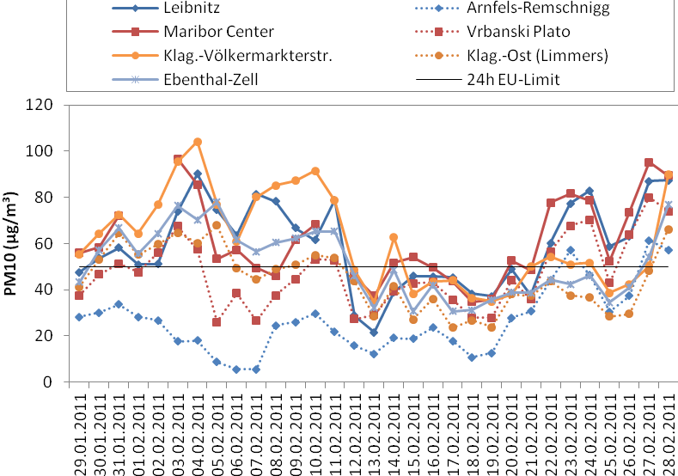

Figure : PM10 concentrations in February 2011 - comparison of PMinter measuring points

The differential analysis between the measuring points in the cities and the background stations provides the 'urban impact', i.e. the additional urban fine dust pollution. It is mainly comprised of motor vehicle traffic, road salt and mineral dust.

Hence, in order to develop effective reduction measures for the winter fine dust pollution, a reduction of local pollution from urban sources as well as a reduction of the regionally effective initial pollution must be targeted.

Differentiation of the proportion of fossil and non-fossil carbon from 14C measurements makes a comparison possible with the source proportions of wood smoke (non-fossil carbon) and traffic (fossil carbon) determined using the macrotracer model. Here, comparable trends were found between the individual measuring points as well as for the absolute concentration values.

**Literature**

Guideline 2008/50/EC of the European Parliament and Council of 21 May 2008 on air quality and clean air for Europe, official journal of the European Union, L 152/1.

F. Cavalli, M. Viana, K. E. Yttri, J. Genberg, J.-P. Putaud: Toward a standardised thermal-optical protocol for measuring atmospheric organic and elemental carbon: the EUSAAR protocol. Atmos. Meas. Tech. Discuss., 2 (2009) 2321–2345

Y. Iinuma, G. Engling, H. Puxbaum, H. Herrmann: A highly resolved anion-exchange chromatographic method for determination of saccharidic tracers for biomass combustion and primary bio-particles in atmospheric aerosol. Atmospheric Environment, 43 (2009) 1367–1371

A. Limbeck, M. Handler, B. Neuberger, B. Klatzer, H. Puxbaum: Carbon-Specific Analysis of Humic-like Substances in Atmospheric Aerosol and Precipitation Samples. Analytical Chemistry, 77 (2005) 7288 - 7293.

H. Bauer, I. Marr, A. Kasper-Giebl, A. Limbeck, A. Caseiro, M. Handler, N. Jankowski, B. Klatzer, P. Kotianova, P. Pouresmaeil, Ch. Schmidl, M. Sageder, H. Puxbaum and the AQUELLA – TEAM: Final report for the "AQUELLA“ project Carinthia/Klagenfurt Aerosol sources analyses for Carinthian PM10 filter analyses according to the "AQUELLA method". Vienna, 2006, US Number: 436/1699/04, Report no. UA/AQKärnten/Klagenfurt 2007 161S, 2006.

C. Schmidl, I. Marr, A. Caseiro, P. Kotianova, A. Berner, H. Bauer, A. Kasper-Giebl, H. Puxbaum: Chemical characterisation of fine particle emissions from woodstove combustion of common woods growing in mid-European Alpine regions"; Atmospheric Environment, 42 (2008) 126 - 141.

H. Bauer, A. Kasper-Giebl, N. Jankowski, A. Dattler, P. Pouresmaeil, C. Ramirez-Santa Cruz, C. Schmidl, G. Peng, H. Puxbaum: "AQUELLA" Analytik von Feinstaubproben der Stationen Kittsee und Heiligenkreuz (Chemical analysis of fine dust samples from the Kittsee and Heiligenkreuz stations)”. Report no. UA/AQBurgenland 2009 55S, 2009.

S. Szidat, T. M. Jenk, H.-A. Synal, M. Kalberer, L. Wacker, I. Hajdas, A. Kasper-Giebl, U. Baltensperger: Contributions of fossil fuel, biomass burning, and biogenic emissions to carbonaceous aerosols in Zürich as traced by 14C. Journal of Geophysical Research, 111 (2006) D07206.

