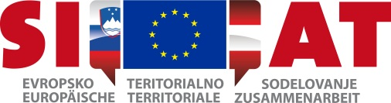

**PrEPARATION OF THE AIR QUALITY MANAGEMENT PLAN FOR Maribor**

**Brigita Čanč, Inter-municipal Office for Environmental and Nature Protection, brigita.canc@maribor.si**

***Summary***

The ministry responsible for the environment is the responsible ministry in Slovenia for the preparation of Air Quality Plans in cooperation with the local communities where the threshold values for PM10 were exceeded. In February 2012, the Working Group for the elaboration of the plan that is divided into two thematic subgroups, i.e. transport and spatial planning as well as efficient use of energy and renewable energy sources, was established at the local level in Maribor. The City Municipality of Maribor is preparing the plan within the PMinter project.

The Air Quality Plan consists of two parts – a legal act/ordinance and an annex containing the description of excessive pollution areas, situation analysis of pollution, sources of pollution, the impact of pollution sources, pollution abatement measures and responsible authorities for the implementation of measures. The measures focus on the areas of energy and transport.

The plan is now in its final stage of harmonisation and we expect that it will be approved by the City Council in autumn, to be followed by the adoption by the Government of the Republic of Slovenia.

