Registration form
for the International Conference of the project PMinter

September 18 – 19, 2013
Hotel City Maribor, Ulica kneza Koclja 22, Maribor

First Name: ________________________________________________________________

Family name: ______________________________________________________________

E-mail: ____________________________________________________________________

Phone: ___________________________________________________________________

Registration for the conference as:
Participant
Lecturer
Project Partner

Name of the institution: ______________________________________________________
Address: _________________________________________________________________
City: ________________________________________________
Zip: _________________________________________________
State: _______________________________________________

Field of interest:
Air quality measurements
Modelling
Impact of the air quality on health
Measures for improvement of air quality
Good practices - air protection and sustainable mobility measures
Participation in the conference, including lunch, dinner and snacks, is free of charge.

Participation at the conference on:
Wednesday, 18th of September 2013 / plus dinner YES NO
Thursday, 19th of September 2013 / plus afternoon activities YES NO

Specific requirements you would like to communicate to us (diet, etc.):

_________________________________________________________________________

Please send the completed application form by email to: pminter@maribor.si no later than 30. 8. 2013. For further information, please contact us at the following telephone number: 00386 2 22 01 445 or at pminter@maribor.si.

Possibility of accommodation in Hotel City Maribor:

As participant of the International Final Conference PMinter you can book a room at a favorable price until 15. 8. 2013 at Hotel City Maribor. When making reservation via info@cityhotel-mb.si, please mention the code “PMinter”. Accommodation costs are covered by participants.

Price is per room.

Room Type | Single Room | Double Room
Standard Room | 75 EUR | 110 EUR
Superior Room | 90 EUR | 130 EUR

Prices include:
- Accommodation in selected room
- Buffet breakfast
- Internet access in the room
- Parking in the hotel garage

Tourist tax (1,01 € per person per day) is not included in the price. For more info on the hotel visit http://www.cityhotel-mb.si.

There are parking possibilities at Hotel City Maribor.
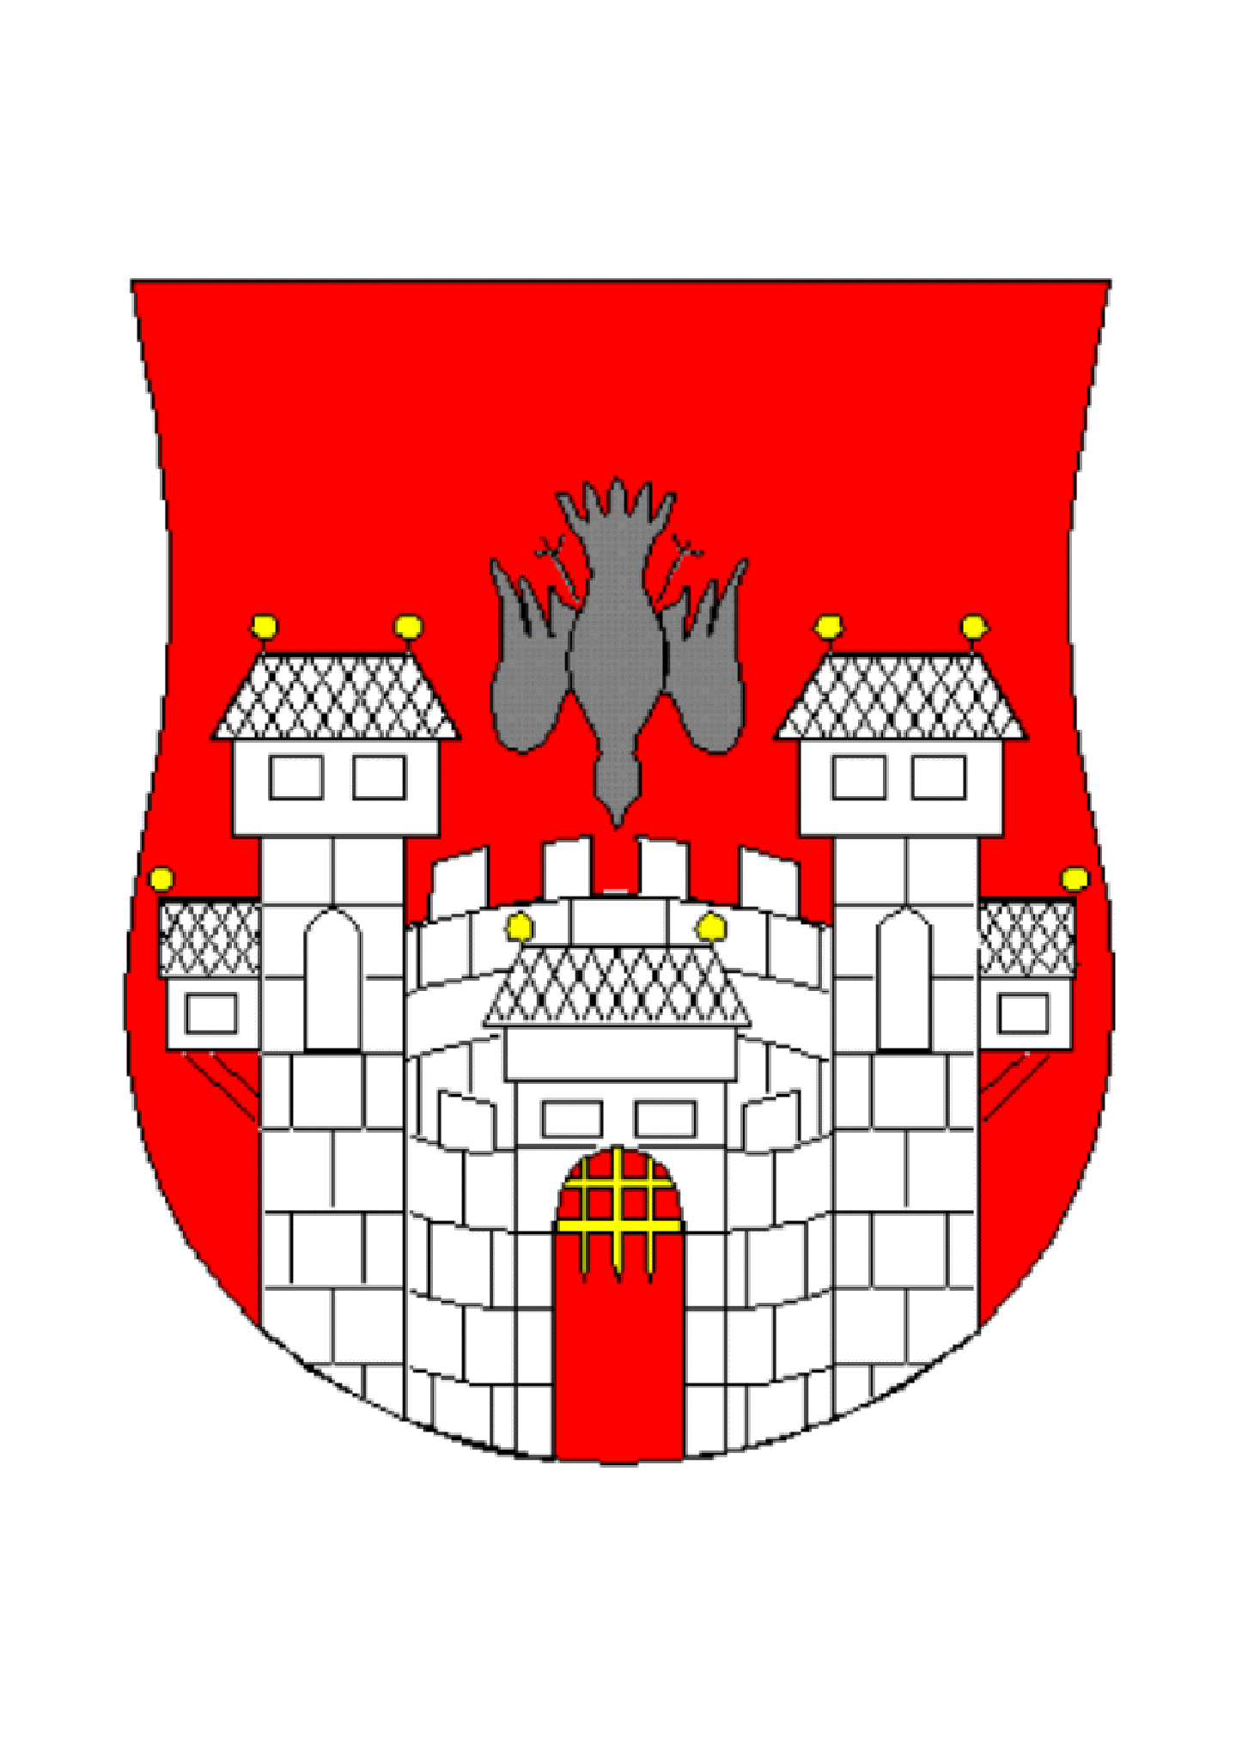
MUNICIPALITY OF
MARIBOR

