Additional measuring site in the pilot environmental zone under the PMinter project

The pilot environmental zone in Maribor, SLO, is valid since 1. October 2012 and was implemented in the with the intention to reduce the air pollution with PM10, NOx and O3 resulting from the road traffic and to change the old habits of people who still prefers to come into the city centre by car (see also 3rd newsletter).

Parallel to the regular measurements of ambient air quality in Maribor and neighboring municipalities, we established one additional measuring point in the pilot environmental zone where PM10, PM2.5 and air temperature is being measured, additional also counting and classification of traffic is performed. Measuring spot is called “Krekova/Tyrševa” and was established on 1st of August 2012 (traffic counts on 17th of September 2012). It is aimed to track changes in air pollution due to impact of operation of the pilot environmental zone and determination of link of air quality with traffic volume and its structure.

The measurement datas are downloadable on the PMinter Homepage www.pminter.eu

http://pminter.eu/de/arbeitspakete/luftguetemessungen/luftguetedatenbank.html

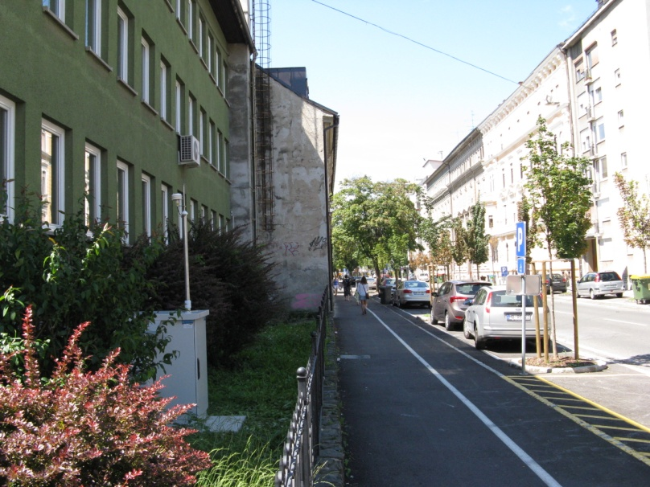

Measurements of PM10, PM2.5 and air temperature are carried out with GRIMM, series 180 device. Amount of traffic and its structure is deemed with induction loop in the road, that separates vehicles to 10 (respectively 11, because of unrecognized vehicles) categories. Counting works with 99 %, classification with 95 % precision.

